MCB READING COMMITTEE APPROVAL PROCESS

The Graduate School uses an electronic process to approve dissertations. Reading Committee members will log-in to MyGrad Program using their UW NetIDs to approve dissertations. This electronic approval improves students’ experience getting final approval of their dissertation by allowing members to approve from wherever they are in the world.

Contact Maia Low with any further questions.

Here are instructions and screenshots of the process:

- Log into faculty interface for MyGrad using your UW NetID credentials.
- Click on the appropriate student’s name under the “Dissertation Approval Needed” section.
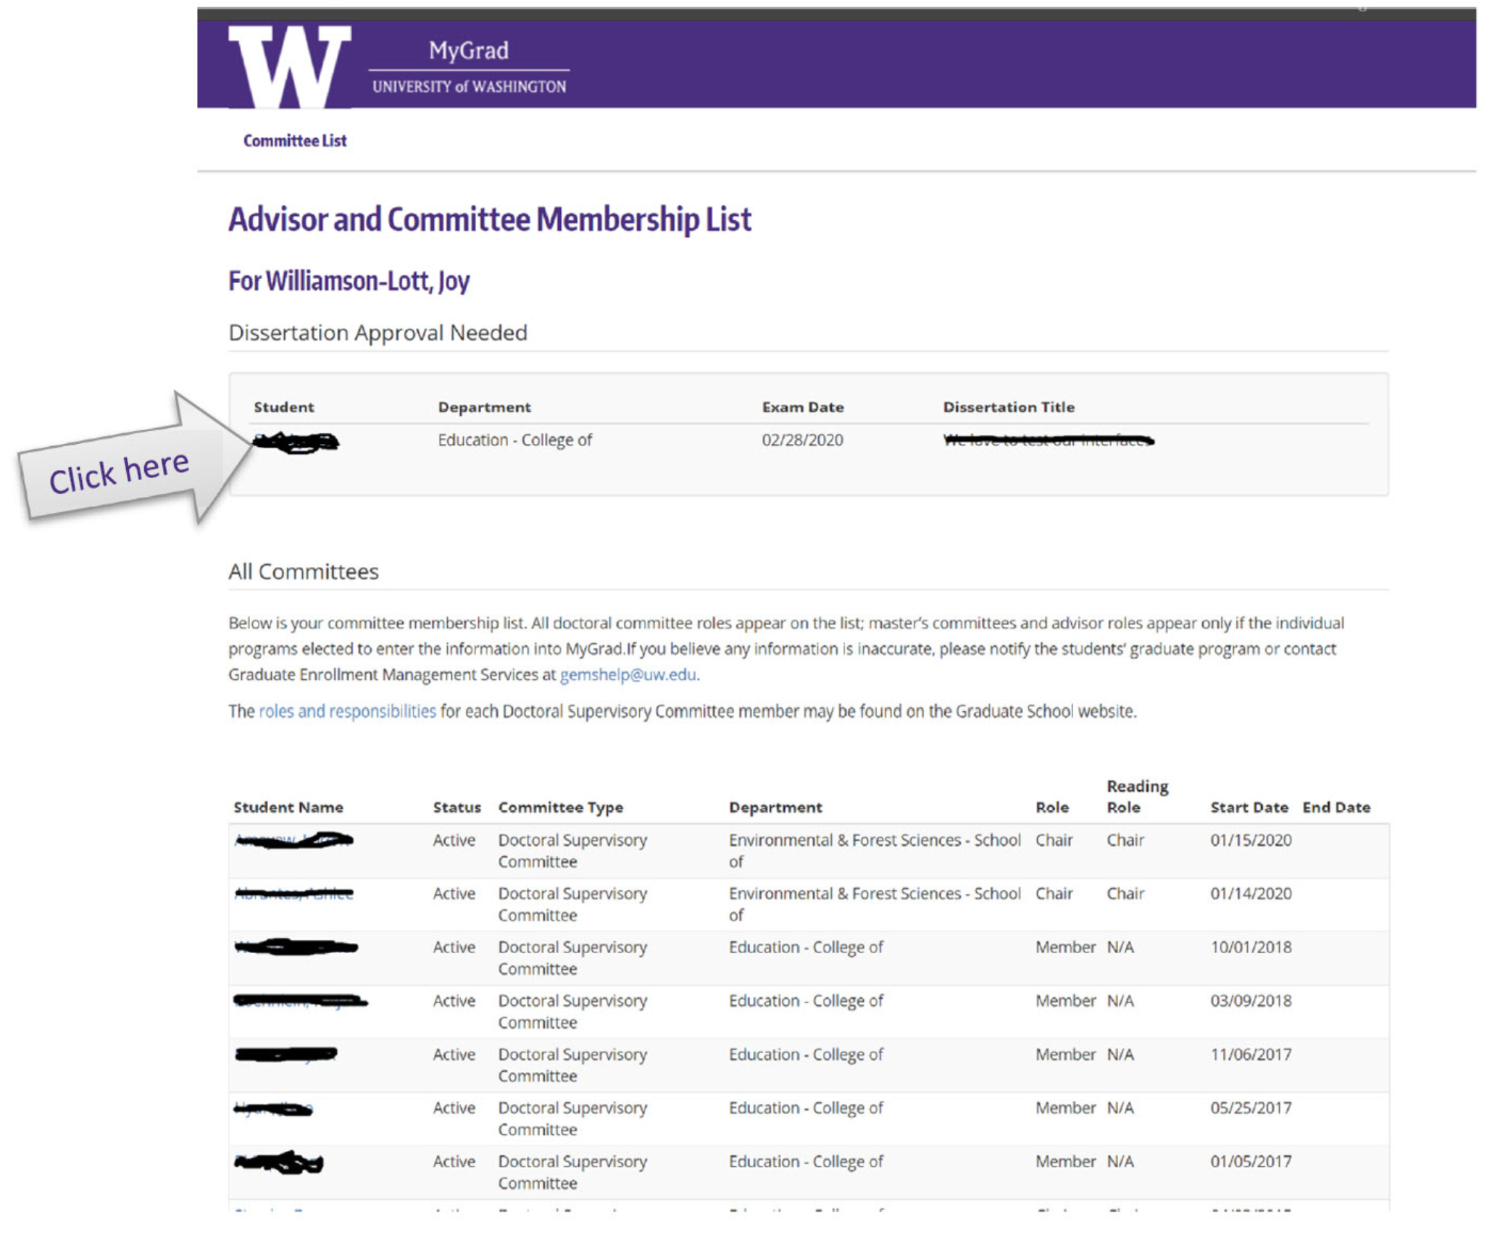

3. Check the certification box and click the “Approve” button.