MCB Remote Annual Committee Meeting Instructions

If you need to hold all or part of your Annual Committee Meeting remotely, we recommend following these instructions.

Annual Committee Meeting Report And IDP Signatures
Your completed annual committee meeting report must be signed by you and all committee members attending your meeting. Your Individual Development Plan (IDP) must be signed by you and your PI. Signatures must be in the form of one of the following:
- Signed by hand
- Adobe digital signature
- DocuSign signatures

1 day before meeting
- Send your presentation slides to committee members
- Include slide numbers on the slides in case a committee member loses their video connection
- Send Zoom meeting invitation and details

Setting up a Zoom meeting

- Go to https://washington.zoom.us/.
- Sign in to ‘Standard UW Zoom’ with your UW NetID credentials.
- Under “Meeting”, click “In Meeting (Basic)”
  - Chat: Enable
  - Select “Prevent Participants from saving chat” and select “Save”
  - Whiteboard: Enable
- Click ‘Schedule a Meeting’
- Topic: Enter the Name of the Committee meeting
- When: Select the correct date; select 30 minutes before the time of your meeting for set-up time
- Duration: 2 hours and 30 minutes
- Time Zone: Confirm it is set to Pacific Time
- Registration: Not required
- Meeting ID: Generate Automatically
- Meeting Password: Not required
- Video Host: On
- Video Participant: On
- Audio: Both
- Meeting Options:
  - Join before host: Disable
  - Mute participants up entry: Enable (Participants can unmute themselves after they join)
  - Enable waiting room: Enable
  - Only authenticated users can join: Leave blank
  - Record the meeting automatically: Leave blank
- Click Save

Zoom generates an invitation link you can send your committee members. You can also copy the invitation, which provides call-in information.

Adding a co-host
You can add your PI as a cohost of the meeting so they can help facilitate. Your PI can also manage Breakout rooms if needed.

Recording your meeting
You are welcome to record your committee meeting, especially if a member can’t attend and would like to watch it. Please be aware that Washington is a 2-party consent state for recording interactions. When you start recording, Zoom will send a message informing participants that recording has started and that they can leave the meeting. Discussions in the Breakout Rooms are not automatically recorded.

Audio and video troubleshooting
Here are some recommendations if committee members have problems with their audio or video:
- Turn off all but speaker video/audio if connection becomes problematic via “Manage Participants” at the bottom of the video screen
- Use the “Call in to meeting” function if computer audio is not working

Facilitating questions
At the beginning of your meeting, you can inform committee members about asking questions. You and your PI may decide to have your PI direct questions to ensure a smooth flow. If a committee member has lost their audio, they can also submit question through the Zoom chat window.

Sharing your screen
You can share your screen via the Share Screen function at the bottom of the video screen. Make sure to share the correct screen as there will be multiple share options.

Breakout Rooms
Breakout rooms are helpful if your committee wants to have a discussion without you or your PI. Click on the Breakout Room icon in the meeting toolbar:
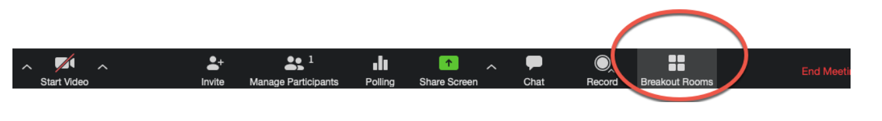
Select the number of breakout rooms. Select “manually” and assign participants to a room.

Submitting Annual Committee Meeting Documents
Submit the following required documents via the Annual Committee Meeting Documents Portal:
- Signed Annual Committee Meeting Report
- One page research summary
- Updated and signed IDP
- List of publications

You will be required to log into the documents portal with your UW NetID credentials. We recommend opening the site in an incognito window of your browser.

